JAPAN’S OVERSEAS DEVELOPMENT ASSISTANCE: ASSESSING CONFORMANCE WITH SHIFTING PRIORITIES

Introduction

Since 1989, Japan has been the single largest aid donor in the world through its Overseas Development Assistance (ODA) program (with the exception of one year – 1990). This largesse has not been without controversy, however. Criticism of Japan’s ODA has been widespread. Admonishments include charges of a heavy skewing toward bilateral assistance rather than through multilateral entities and an overemphasis on tied aid and loans rather than untied aid and grants. Furthermore, and particularly poignant after the 1991 Persian Gulf War, were charges that Japan relied exclusively on “checkbook diplomacy” without more substantive sacrifices in the U.N. Security Council sanctioned effort. Another criticism surrounds Japan’s use of ODA as paving access for its transnational corporation (TNC) involvement and profit-taking, as the lion’s share of projects it supports involve economic infrastructure development rather than those aimed at human development – such as meeting basic human needs (BHN) or promoting good governance and social services. Finally, criticism has been leveled at Japan for taking a predominantly regional orientation with its assistance rather than a global perspective. Until 1992 Japanese ODA decision-making had no principle-based guidance. The Yoshida Doctrine carried the day - emphasizing economic development and a low diplomatic profile. To redress criticisms, Japan wrote its first ODA Charter in 1992 and revised it in 2002.

Fundamentally, ODA provision would be utilized as an incentive rewarding those countries making progress on their democracy and economic liberalization records. The research question driving this study is whether or not current Japanese ODA lending is reflective of policy reorientation that rewards democratization and market-oriented economics.
The aim here is to assess the degree of conformance of Japan’s aid provisioning to its policy goals as found in its charter. The following questions drive this investigation:
- To what degree has Japan’s ODA distribution diversified since 1992?
- Has there been a significant movement in emphasis from infrastructure and transportation (i.e. physical development) to humanitarian, social infrastructure, and BHN efforts (i.e. human development)?
- Has there been more emphasis on aiding regional multilateral efforts over time?
- Is there evidence that Japan has made good on its pledge to give priority in assistance to those contexts with improving democratization records and market-based economic structural adjustments?

Japan’s first ODA Charter in 1992 addressed the philosophical role Japan should play internationally commensurate with its power position in the world. Being limited to anything other than financial benefactor stem from its pacifist international orientation as found under Chapter IX of its constitution coupled with regional wariness of Japanese intents given its history of militarism through WWII. Playing the nearly singular card it possesses to affect international relations, the 1992 Charter sought to fulfill a positive role by focusing on those aspects of development in developing countries vital to the prospects for peace and prosperity domestically and that of the world. Toward this end, the Charter emphasized the need for good governance, fair and efficient distribution of resources, developing human resources and infrastructure, and meeting BHN in these contexts. What we have here then, is a commitment to place more conditions on loans and grants that take into consideration the political conditions of potential recipients.

Japan revised its ODA Charter in 2002 to reflect a changing world by recognizing new challenges for development in the form of peace-building and the importance of international organizations. Philosophically there was more definition of intent under the revised Charter compared to the original. Recognitions and commitments are found as follows:
…conflicts and terrorism are occurring more frequently and they are becoming even more serious issues. Preventing conflicts and terrorism, and efforts to build peace, as well as efforts to foster democratization, and to protect human rights and the dignity of individuals have become major issues inherent to the stability and development of the international community. (Ministry of Foreign Affairs - MOFA, 2003)

Clearly this is in response to a post-9/11 changed security environment. Notable policy emphases in the 2002 Charter charge Japan to give priority to assisting those developing world contexts that make “active efforts” in the pursuit of peace, good governance, democratization, human rights, and structural social and economic reform. The 2002 Charter, comparatively speaking, commits Japan to a more vigorous endeavor to attend to these issues. If Japan makes good on its pledges, it will reap more prestige as a responsible global actor.

This study is the first of its kind in assessing the degree to which ODA lending reflects pledges to consider democratization and market orientation performance. The revised 2002 ODA Charter commits Japan to review the records of potential recipients on these issues. Utilizing the Bertelsmann Index, this study compares the performance of ODA recipients on two of its indices with changes in ODA lending emphasis.

This study is intended to be a review of conformance, not performance – meaning that it focuses on the allocation of aid funding to recipients with regard to shifts in ODA priorities. Performance assessment – the effectiveness of aid in pursuit of goals is something better left to field research and is necessarily beyond the scope of this investigation.

The Debate
Until 1992, Japan’s Overseas Development Assistance (ODA) has been rudderless. Beyond a few regional cases of WWII reparations to countries that agreed to accept offered assistance, there was no sense of purpose or direction for aid – at least until the wake of the 1991 Persian Gulf War. It was with Japan’s ascendance as an economic superpower in the late 1970s that its overseas aid assistance came under closer scrutiny and criticism by foreign observers. As Japan’s economic power and trade balances soared, many in Europe and the U.S. castigated Japan for not taking a more substantive role in countering the Soviet Union. Nakanishi (2002) finds that under the Ohira Cabinet, “Japan began to use ODA as a political tool to complement, if not substitute for, Western efforts against Soviet expansionism, especially in developing countries” (177). The degree of censure of Japan’s free-riding and ODA reached a crescendo after the 1991 Persian Gulf War.

While Japan picked up the bulk of the tab for the cost of prosecuting the UN-sanctioned Gulf War ($13 billion), it was disparaged by others as merely “checkbook diplomacy” - ill-fitting a country of Japan’s stature. Japan responded the following year by formulating an ODA Charter detailing its principles, goals and issue priorities. Certainly given Japan’s pacifist orientation, the limitations of Article IX, and regional fears of resurgent militarism restrict Japan’s latitude in applying coercion beyond economic sanctioning. Due to its economic vulnerability in terms of resources it has been reticent to apply punishments.

Given these limitations and necessities, Japan’s approach to assuring regional security contrasts that of the United States. Generally speaking, the U.S. has taken a “stick” approach to regime change by way of economic sanctioning of authoritarian states that impose on democracy and human rights. In contrast, Japan has taken, for want of a better expression, a cooptive approach utilizing its ODA to encourage democratization and respect for human rights – contesting that economic development is fundamental in giving rise to a politically moderating and participatory middle class. The problem here is readily apparent – if a country is negatively sanctioned by one and is buoyed by another - even if the goal of regime change is shared, it necessarily challenges the prospect of an optimal outcome.

Partly arising from criticism that Japan’s strategy has bolstered rather than undermined authoritarian governance, its 1991 Diplomatic Bluebook for the first time approved a goal of “promoting universal values” emphasizing liberal politics and human rights. This was evidenced the following year in Japan’s first ODA Charter stating that it would consider democratization and human rights records of potential ODA recipient states in decision-making. Here then we can see another shift in foreign policy orientation toward a more global perspective and sense of responsibility. This holds consequence for Japan’s heretofore heavily weighted attention to Northeast and Southeast Asian affairs.

Given Japan’s lopsided power profile favoring economic might, ODA has and continues to be the preeminent means by which Japan seeks to assert its influence. Miyagi (2008) contends that, given Japan’s deep concern about involving itself in the internal affairs of other states, a function of its regret regarding WWII aggression, the use of economic assistance as a substitute for other foreign policy means is easily extended to all other regions of the world (43).
The obvious, and at least for the near-term, most viable option for Japan to play a more meaningful global role is a reorientation of its ODA foci. Smith (2003) observes that the 1992 ODA Charter meant that
[A]lternative mechanisms for demonstrating Japan’s commitment to assisting the United States in contributing to global security were found. Japan vastly increased its Overseas Development Assistance Aid (ODA), and began direct economic assistance to key states in unstable regions around the globe. Japan demonstrated its shared security commitments with the United States by economic means, and on a global scale (126).

So, as meaningful as this shift is, it can be viewed as an extension of a “checkbook diplomacy” approach to foreign affairs policy. Japan has not scuttled its economic development strategy toward assuring democratization in a comparatively passive and indirect manner. Japan’s 1995 ODA White Paper (MOFA, 1995) affirms that “economic development and stability form important foundations to the democratization and the introduction of a market economy.” This affirmation serves two purposes, one political and one pragmatic. The former involves continuity with past policy orientation and helps reassure those regimes with less than full democratic credential that Japan will continue the aid pipeline thereby maintaining a modicum of stability in standing relations. The latter purpose stems from economic necessity given Japan’s vulnerability due to limited natural resource endowments, etc.

By no means mutually exclusive, the criticisms leveled at Japanese ODA are as follows: 1) the “tying” of aid to Japanese corporate interests; 2) a dominant emphasis on economic infrastructure development; 3) too strong an emphasis on bilateral aid; 4) the stronger emphasis on loans rather than grant monies (compared to other major donor countries); 5) a weak record of supporting human development and meeting basic human needs; 6) too much of a Southeast Asian regional focus; and 7) lack of “principle-driven” ODA decision-making promoting values such as democratization, human rights and market liberalization.
Lujan (2001) argues that tied aid refers to a preference for loans, debt-servicing and development projects that “ultimately benefit Japanese corporations and Japanese national interests” (1). He further charges that untied aid necessarily subordinates recipients to Japanese business interests as the project specifications necessarily require use of Japan Industrial Standards – meaning that, “even if local companies win bids, they have to purchase all materials from Japan. It becomes, in reality, a way to sell Japanese products” (7). A 1993 State Department Report criticizes Japan’s aid program as improperly subsidizing commercial exports by Japan’s private sector. Not only is Japan’s ODA still “tied” to Japanese companies, it says, since Japanese companies solidify their advantageous footing by maintaining close ties to both the Japanese government and the governments of developing countries, it is easy for them to acquire project contracts even for aid that is not tied. Moreover, “[E]ven the Federation of Economic Organizations (Keidanren) has clearly expressed the view that Japan’s foreign aid is both a natural and proper way to expand Japan’s commercial interests.” Complaints that both loan and grant ODA necessarily support Japan’s corporate interest abound.

Clear (2008) notes that while part of the critique surrounded the issue of “massive profits accruing to Japanese commercial interests, another component of the critique was that so little of Japanese ODA incorporated civil society, not only in Japan but also in recipient countries” – thus hinting at the incongruence of profit-seeking with meeting human development and BHN needs (231). Padilla (2008) asserts that, “[T]he relationship between ODA and Japanese corporate interests as exemplified by tied aid explains why the Japanese government is more interested in infrastructure development rather than in fulfilling basic human needs in Third World countries” (26). Commenting on the claim that the general focus of Japan’s ODA is on “economic infrastructure” and is thus remote from people’s lives or from basic human needs (BHN), Akira and Yasutami (1999) counter that “many of the economic infrastructure construction projects…are aimed at rural and regional development and are neither large in scale not exclusively related to industry. Moreover, their BHN element is profound” (218).

Certainly bilateral assistance offers greater opportunity to affect the recipient’s policy preference orderings more directly than does that accepted from multilateral agencies. However, payoffs to the donor are to be had with those made through multilateral agencies also. Nakanishi (2002) notes that even though “Japan was totally unprepared for an era in which the United Nations activities could have military implications of large-scale warfare could take place” (184-185) and according to Tanaka (in Clooney, 2002) possesses “no missionary zeal to help the world” (190), Japan has chosen to adopt United Nations missionary objectives as its own for foreign policy guidance. Some field research supports the contention that gaiatsu (roughly, following another country’s lead) does not play any significant role in Japan’s foreign policy decision-making. Clooney’s 1998 field interviews found that “that not a single interviewee believed that Japan should undertake a “world leadership role” with the majority (78%) saying that Japan could not do so, and 22 percent responding that they “did not know.” Given his remarks regarding the general disinterest of the Japanese public in foreign affairs, he concludes from this that,
[I]t is for this reason that Japan is continuing its pursuit of a United Nations-centered foreign policy. The United Nations is critical to Japanese foreign policy, in that its peaceful ideals reflected in the U.N. Charter conform to the pacifist sentiments in Japan and its constitution. It is for these reasons that the United Nations is likely to remain the focus of Japanese foreign-policy efforts outside of its bilateral relations with the United States (191).

With regard to ODA disbursement, Patrick (2008) statistically confirms that Japan has been by far the largest bilateral donor to the Association of Southeast Asian Nations (ASEAN) countries. However, he notes that as Japan’s “national interests” have evolved (suggesting here a more global and independent foreign policy vision), “so too has its geographic distribution of ODA…disbursements to Southeast Asia in 1993 amounted to 29.9 per cent of Japan’s total aid…in 2004 (it) was only…15.2 per cent…” (201). On a related note regarding the issue of support for multilateral regional aid agencies, Krauss and Pempel (2004) observe that although Japan receives much more criticism for most of the above-mentioned reasons than does the United States, it provides more resources to multilateral organizations in the Asian region and thus gains from the opportunity “to become a more “normal” nation, not only in security, but equally important, politically and diplomatically” (319).

In response to criticism and borne of the necessity to recognize and react to a changing international relations environment, Japan has issued both a vision for its ODA in its 1992 Charter and a revision of that Charter in 2002. In what would become the guidance for ODA under the 1992 Charter,
[I]n April 1991, then-Prime Minister Kaifu Toshiki announced four major ODA policy principles that the Japanese government would henceforth consider when deciding whether to extend ODA: the recipient country’s military spending; its arms exports and imports; its development and production of such weapons of mass destruction as nuclear missiles; and its efforts to promote democratization, ensure human rights, and move toward a market-oriented economy.

This then comprises Japan’s issuance of standards to guide ODA decision-making regarding the qualifications of potential recipients. What is of note here is the fact that much of the statement centers on measureable defense and security issues and, as such, fails to provide anything in the way of philosophy and moral justification for direction of Japanese foreign policy.

Comparatively speaking, the revisions of 2002 add more philosophical depth and establish a set of principles to guide ODA decision-making…
The most important philosophy of Japan’s ODA is to support the self-help efforts of developing countries based on good governance, by extending cooperation for their human resource development, institution building including development of legal systems, and economic and social infrastructure building, which constitute the basis for these countries’ development…Japan will give priority to assisting developing countries that make active efforts to pursue peace, democratization, and the protection of human rights, as well as structural reform in the economic and social spheres…Japan will enhance cooperation with international organizations that possess expertise and political neutrality…Full attention should be paid to efforts promoting democratization and the introduction of a market-oriented economy…

While some research has noted movement in ODA toward untied “grant” aid, diminished emphasis on economic infrastructure spending, and greater assistance lent to multilateral organizations, etc. this study not only reaffirms these shifts in ODA but seeks to assess the degree to which ODA has conformed to the guidance principles of rewarding democratization and market-orientation efforts of recipients – issues that the present literature does not address.

Methodology

The research goals of this study are numerous. Investigated here are a number of considerations concerning Japan’s ODA that tap into critical issues of its attempting to foment a more global role including emphasis on the promotion of BHN, human development, good governance, and economic liberalization. These include:
- The geographic distribution of aid by regional allocations
- The overall configuration of aid by kind and region
- The percentage of loan aid vs. grant aid
- The percentage of bilateral aid vs. multilateral aid
- The percentage of aid received by the worst democratization performers within their geographic region
- The percentage of aid received by the worst market orientation performers within their geographic region
- The percentage of aid received by the combined worst democratization and market orientation performers within their geographic region

OECD-DAC data were relied upon for this study. DAC data provide a lengthy list of categorized aid types. Most major DAC categorizations were utilized for this study and are as follows:
Category #1: Social Infrastructure
Category #2: Improving Governance
Category #3: Economic Infrastructure
Category #4: Actions Relating to Debt
Category #5: Humanitarian Assistance
Category #6: Disaster and Reconstruction Relief
Category #7: Support to Nongovernmental Organizations
Category #9: Unspecified Aid

Given limited space within charts and graphs for text and the crowding that would result, most provide only type of aid by its numeric code. A detailed list of utilized DAC descriptions and their CRS coding are provided in Appendix #1.

The data account for nearly all kinds of CRS aid. The only major categories of aid omitted from the study are “Multisector/Cross-Cutting” (which include General Environmental Protection and Urban Development); “Commodity Aid and General Program Assistance (which include General Budget Support and Other Commodity Assistance); “Refugees in Donor Countries”; and “Unallocated/Unspecified” aid as these did not fit into the parameters of the study. There were significant changes in Japan’s reporting to the OECD in order to fulfill promises of greater transparency (one of the goals of the 1992 Charter and its subsequent revision). This resulted in great “jumps” in amounts (reported in U.S. dollars) and utilizing these would unnecessarily obfuscate treatment and interpretation of the data. As a consequence, only percentages for comparative purposes are provided.

I have chosen to investigate those cases of poorest record evidencing declining democratization and market orientation precisely because reliance on more general data reflecting ODA allocations by region and kind overall may very well veil the reality of specific cases. In other words, given that Japan is the largest ODA donor in the world, it might be easy to overlook specific cases where the amounts of aid are small. The devil is always in the details. Furthermore, through more intensive scrutiny of these poor or declining performers, we can get a more accurate accounting of Japan’s conformance since it is these kinds of cases that should be most reflective of Japan’s changed ODA priorities. A reasonable expectation is that we should see a decline in aid funding to those recipients demonstrating declining records of democratization and market orientation if Japan is truly interested in taking a leadership role in promoting these ends and is abiding by its pledges. Maintenance of or increasing support, particularly after 2003, would indicate that Japan is not fully committed to bringing about change. One caveat is in order however. If the commitment of aid remains steady or increases, it will be important to note the configuration of that aid by category as this may reflect an effort to induce policy change by the recipient rather than through coercive means.

In order to assess conformance of ODA to a shifted set of principles and priorities emphasizing democratization and market orientation of economy; this study utilizes the Bertelsmann Index that scores a country’s performance on “Democracy Status” and “Market Economy Status”. A disadvantage of these data is that only a composite score is provided for ranges of years; there are no year-by-year data. This necessarily limits the degree of methodological sophistication that can be applied to the research. On a positive note however, the time periods fit rather neatly with the revision of the ODA Charter in 2002 – the composite status score for the first period of years with Bertelsmann being 1998-2003 and the second period, 2004-2007 (Jan.), as luck would have it.

The democratization score for the entire period of the Bertelsmann Index (1998-1/2007) is calculated by subtracting Bertelsmann’s 2007 “Democracy Status” score from the 2003 score. This difference, if a negative number, reflects a decline in democratization. The same method was applied to “Market Economy” scores. Taking the average of all decliners on these measures, the worst decliners are identified and selected if they are found above the 50th percentile. Since all European Union countries were essentially phased out of Japanese ODA support in the 2003-2006 period (as Chart #2 shows), they were eliminated from consideration in the investigation for those aspects of the study to which this period exclusively applies. This elimination is reasonably justified because, I believe that dropping out European Union countries from ODA assistance is systematic and their evidenced elimination of aid support is not particularly a function of their poor performance. Their continued inclusion in the data set would likely skew the results of this study. Comparatively speaking, Japan has continued aid support in all other regions of the world (albeit with some showing declines – but not elimination such as that found with Europe). There were a couple of cases of “decliners” on democratization or market orientation for which there was no aid given in the Bertelsmann Index period of 1998-2003 (Somalia and North Korea). With no data to compare to the later period when aid was sent, they were dropped. Regions of the world are coded as found in Appendix #2.

The data reflecting changes in these statuses over the entire time period recorded in the Bertelsmann Index is a bit more complicated and tenuous for interpretation. For the period 1993 to 1998, Bertelsmann offers only a composite overall “Status” score that includes measures of “Management Performance” as well as a “Management Index” (which are outside the interests of this study) in addition to the Democracy and Market Economy Statuses. In order to identify the worst performers over the entire period of the Bertelsmann collection, an unavoidable assumption is necessary – that those countries found in the “Overall” Status Index from 1993-1998 were necessarily poor Democratization and Market orientation performers – which should not be too great a leap of faith. Portions of this investigation rely on selected cases (those above the aforementioned 50th percentile) that reflect both poor overall statuses in the earlier period and poor performance on Democratization and Market Orientation scores in the 2004-2007 period. Further complicating matters is that the Democratization and Market orientation scores in the 1998-2003 period were incomparable (possibly the result of using different scoring techniques) with those of the 2004-2007 period and were therefore omitted. On a happier note and by luck of coincidence, Bertelsmann’s data starts in 1993 and the original ODA Charter was established in 1992 – again making for a rather nice fit. A listing of 2004-2007 “Worst Democratization Performers” and “Worst Market Orientation Performers” are found in Appendix #3.

In order to assess conformance with policy objectives, this study analyzes the poor or declining performers in two ways. First, these cases are judged on their percentage of bilateral aid as a portion of that to the region to which they belong. We would expect the poorest performers on these measures to experience a decline in Japanese ODA. Second, these cases are analyzed in terms of the types of aid they received during the 2003-1/2007 period. Another expectation is that we should see transitions from economic infrastructure development to other human and social infrastructure development efforts. It is with these cases that we should expect to see the greatest changes in Japanese ODA if serious attention is being given to their democratization and market orientation efforts by aid decision-makers. While notable is the fact that Japan has put more effort toward humanitarian and disaster relief, given the emergency nature of these events, not much insight can be gained by comparison of regions or cases. Only gross expenditures are converted into percentages to reveal the extent to which Japan has diversified its aid range.

Findings
In looking at the bilateral distribution of Japanese ODA geographically, the data demonstrate that Japan has been transitioning from its regional orientation (Asia – totaling 47% of all in 1991 to 32% in 2006) to greater dispersion of aid elsewhere (comparing Charts #1 & #2).
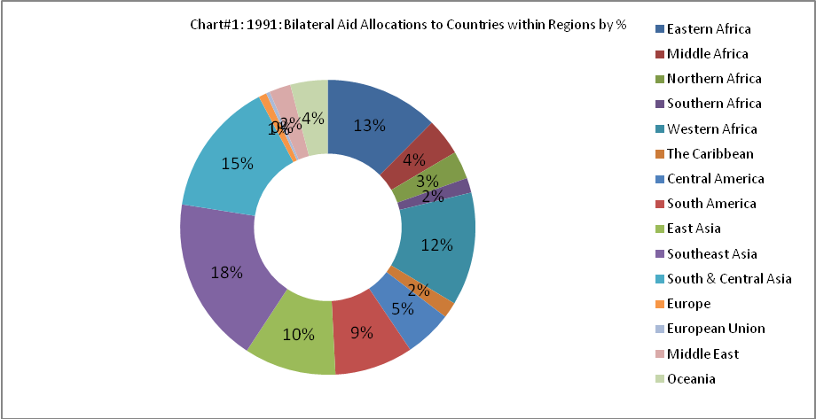
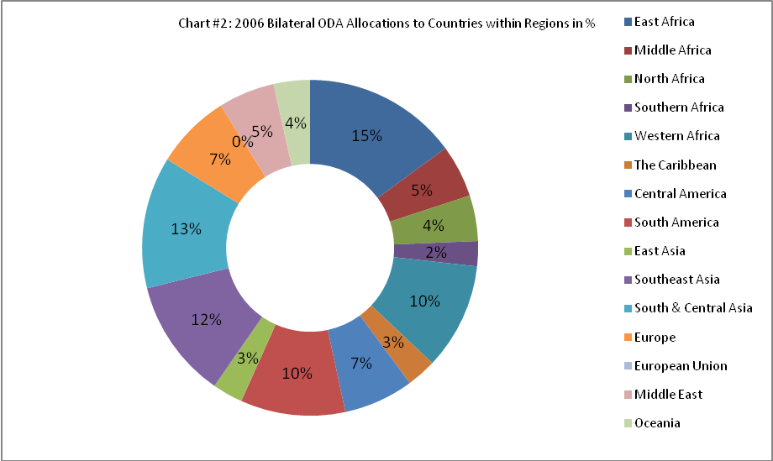
While the Southeast Asia region still captures a significant portion of aid, we should not reasonably expect otherwise given Japan’s history of economic linkage in the region as a function of its proximity, its own self-interest, and as a legacy of commitments given Western interests in having Japan play a stability role in helping counter the Soviet threat during the cold war. This being said however, the 2006 data shows that the largest drops have occurred in East and Southeast Asia (declining 7% and 6%, respectively). South and Central Asia lost 2%. The Middle East gained from 2% to 5%. These increases are a reflection of post-war reconstruction with aid going to aid countries formed after the break-up of Yugoslavia and the Persian Gulf and Iraq Wars in the Middle East. It appears that the other gainers generally picked-up a percent or two. West Africa was the loser at 2%. So, it can be concluded from this that Japan has indeed made good to diversify its ODA spending geographically.

With regard to kinds of aid allocated, Graph #1 shows a clear transition in Japan’s ODA from an “Economic Infrastructure” orientation to “Human Development” and humanitarian aid and disaster relief.
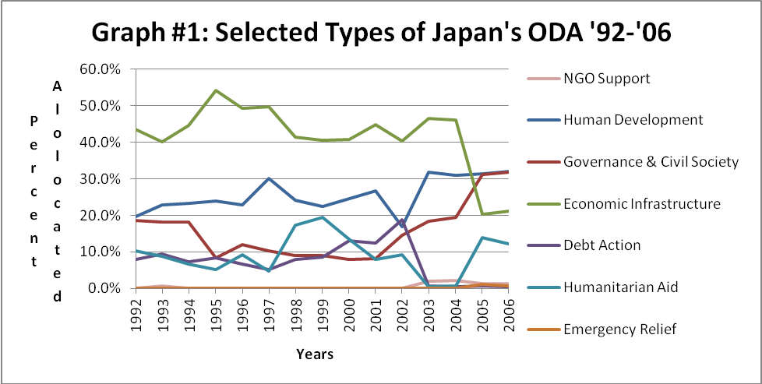

Clearly on the heels of the 2002 ODA Charter revision directed toward human development, improving governance, and humanitarian aid, Japan has transitioned much of its economic infrastructure development funding towards these goals. However, a caveat is in order here - the delineation between human or social development and economic development is not always clear-cut. For example, projects involving schools and hospitals for instance, may have economic infrastructure implications – such as with regard to their construction. Another example might be water works and sanitation; while certainly these can be viewed as social and human development undertakings, they also serve economic development at the same time. DAC places such projects under the category “Human Development” but many might as reasonably be designated as “Economic Infrastructure”.
This being said, the data show about a 25 percent drop in ODA allocated as “Economic Infrastructure” from 2002-2006 while the slack is clearly picked up by Human Development, Governance, and Humanitarian Aid. Thus far and again, the data demonstrate that Japan has indeed made good on its changed orientation commitments. Also notable is the drop in aid in the early 2000s.

Japan has also made good on its pledge to support multilateral efforts (see Graph #2). Prior to 2002 Japan provided very little funding support to these agencies.
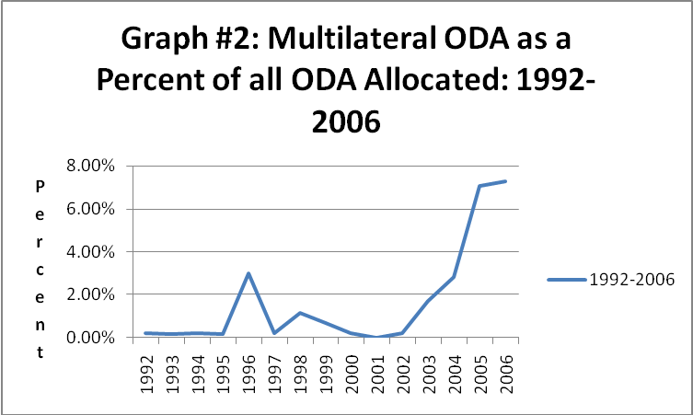
Since 2002 the amount of aid funding has steadily increased and in 2006 found support of over seven percent of all aid. This fact should assist in quelling the critics and evidences that Japan seeks greater voice in the councils of these agencies – a mark of leadership in global purpose.

On the issue of Japan’s predilection for loan aid versus grant aid (compared to major donor countries), the data support this oft-cited criticism of Japan’s lending – until 2003. Once again however we see a substantial shift in orientation toward more grant aid (see Chart #1). Prior to 2003 loans comprised 25-30% of Japan’s yearly ODA lending. After 2003 it is clear that a fundamental shift in ODA occurred. Since the revised Charter went into effect, loans have consistently been in the range of only one to two percent of ODA disbursements (on a par with major donor countries).
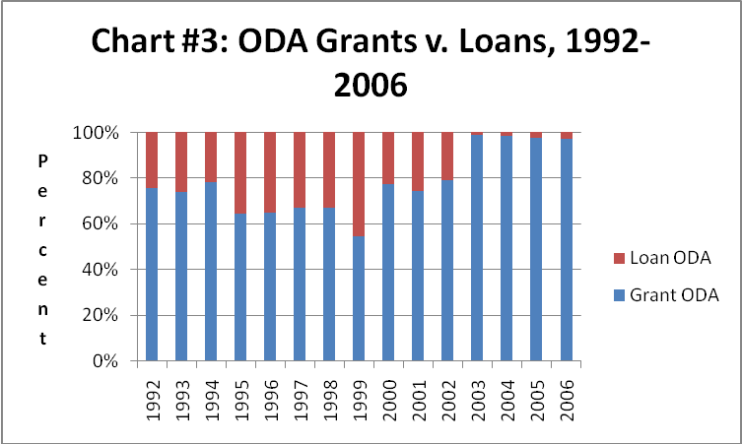
On the macro-level of analysis, so far so good. Findings indicate that Japan has made good on its pledges to make changes in its distribution of aid regionally, in diversifying the kinds of aid it allocates (toward human and social development), in terms of directing more of its aid to multilateral agency efforts and transitioning to almost exclusively grant aid. These findings should take some air out of the tires of the ODA critics.

However, as mentioned before, the devil is in the details. Does Japanese ODA decision-making conform to its vow to consider the potential recipient’s performance on democratization and market orientation criteria? Here the evidence runs largely counter to the pledges found in the revised Charter.

Appendix #4 show some mixed records on the democratization front. Only Thailand and Botswana show steady decline in bilateral ODA funding since 2003. The other seven countries show either some consistency with the degree of Japanese support they received prior to the 2003 Charter revision or an increase in aid – particularly Myanmar and Sudan in the latter case. This is a curious finding given international community attention and criticism of these repressive regimes. Further comment will be held in abeyance until after we consider the types of aid these contexts have received.

Appendix #5 show the same kind of mixed record with regard to market orientation as found with democratization. Eritrea, Rwanda, Iraq, Myanmar and Sudan reflect increases in aid provision even as their scores on market orientation of their economies are in decline. The other six cases show general consistency with the levels of aid they received prior to 2003. Again, these are curious findings.

In haste it might be easy to judge Japan harshly. However this conclusion might not be warranted at this point of the discussion. The Charter vow underpinning this study is that Japan seeks to reduce aid to poor performers. Even though the data support the contrary, we must hold out the possibility that Japan has configured its lending by kind to encourage transitions to democratization and market orientation. While this would be consistent with its general orientation regarding a cooptive rather than coercive approach to international relations, it is inconsistent with giving “priority to assisting developing countries that make active efforts to pursue peace, democratization, and the protection of human rights, as well as structural reform in the economic and social spheres.” It could be the case that Japan has tailored its aid to meet specific challenges in these areas. In this situation, one would expect that aid would be emphasized toward Governance and Civil Society (Type #1), Human Development (Type #2) and Humanitarian Aid (Type #5). Types 1 & 2 would be particularly helpful in order to promote long-term development goals (but Type 5 cannot be ignored either).

Referring to Graph #1 we see that in 2005 and 2006, aid directed at Governance and Civil Society comprised about 32 percent of all aid. In the period 2003 to 2006, Human Development Aid received about 32 percent also. Humanitarian Aid received about 12 percent in 2005 and 2006.

Now let’s compare this with the aid received by the worst performers – selected because they appear on both lists in Appendix #3. In the period 2003-2006 Sudan received 20.6% of Type #1, 24% of Type #2 and 40.1% of Type #5. Cote d’Ivoire received 28.5% of Type #1, 11% of Type #2 and 19.6% of Type #5. Myanmar received 30% of Type #1 aid, 22.4% of Type #2 and 10.2% of Type #5. Morocco received 32.6% of Type #1, 24.8% of Type #2 and 2.3 percent on Type #5. On the particularly important Type #1 and Type #2 aid, only Morocco is on a par with Type #1 aid given to all ODA recipients. Myanmar and Cote d’Ivoire are close. So, it is safe to conclude that if Japan sought to improve democratization and human development (and as far as these lend themselves toward greater market orientation), an assumption of a proactive, capacity building effort is not borne out strongly by the data.

With regard to Humanitarian Aid, notable is Japan’s decided commitment to meeting the needs of those in crisis. With the exception of Morocco and commensurate with the dismal human conditions in the other cases, Japan has made considerable commitment to relieve those mired in civil war.

Conclusion
This study reveals that on many counts Japan ODA has indeed lived up to its vows to diversify its aid portfolio typologically, has taken a more global approach to its aid provision through broader distribution across regions of the world, has given more assistance on grant bases, and has provided more support to multilateral agencies. However, this study indicates that while substantive transformations have occurred at the macro-level of analysis, this belies the fact that Japan has not made meaningful effort to apply criteria regarding improvements in democratization and market orientation as preconditions for aid provision in specific cases. These cases reflect declining performance on these measures yet aid levels have been maintained or increased after the advent of the 2002 ODA Charter. If Japan’s ODA is to be further freed from criticism it must make the bold move to use ODA provision in a coercive manner to bring about regime and policy change. The evidence here shows a greater humanitarian emphasis but does not support any claim to reward only those countries that make “active efforts to pursue peace, democratization, and the protection of human rights, as well as structural reform in the economic and social spheres” as called for in the revised ODA Charter of 2002.

Appendix #1

Appendix #2

 | AFRICA (1)
 | Eastern Africa (1.1)
1.1 | Burundi
1.1 | Comoros
1.1 | Djibouti
1.1 | Eritrea
1.1 | Ethiopia
1.1 | Kenya
1.1 | Madagascar
1.1 | Malawi
1.1 | Mauritius
1.1 | Mayotte
1.1 | Mozambique
1.1 | Reunion
1.1 | Rwanda
1.1 | Seychelles
1.1 | Somalia
1.1 | Tanzania, United Republic of
1.1 | Uganda
1.1 | Zambia
1.1 | Zimbabwe
 | Middle Africa (1.2)
1.2 | Angola
1.2 | Cameroon
1.2 | Central African Republic
1.2 | Chad
1.2 | Congo (Brazzaville)
1.2 | Congo, Democratic Republic of the
1.2 | Equatorial Guinea
1.2 | Gabon
1.2 | Sao Tome and Principe
 | Northern Africa (1.3)
1.3 | Algeria
1.3 | Egypt
1.3 | Libyan Arab Jamahiriya
1.3 | Morocco
1.3 | Sudan
1.3 | Tunisia
1.3 | Western Sahara
 | Southern Africa (1.4)
1.4 | Botswana
1.4 | Lesotho
1.4 | Namibia
1.4 | South Africa
1.4 | Swaziland
 | Western Africa (1.5)
1.5 | Benin
1.5 | Burkina Faso
1.5 | Cape Verde
1.5 | Cote d'Ivoire (Ivory Coast)
1.5 | Gambia
1.5 | Ghana
1.5 | Guinea
1.5 | Guinea-Bissau
1.5 | Liberia
1.5 | Mali
1.5 | Mauritania
1.5 | Niger
1.5 | Nigeria
1.5 | Saint Helena
1.5 | Senegal
1.5 | Sierra Leone
1.5 | Togo
 | THE AMERICAS (2)
 | The Caribbean (2.1)
2.1 | Anguilla
2.1 | Antigua and Barbuda
2.1 | Aruba
2.1 | Bahamas
2.1 | Barbados
2.1 | British Virgin Islands
2.1 | Cayman Islands
2.1 | Cuba
2.1 | Dominica
2.1 | Dominican Republic
2.1 | Grenada
2.1 | Guadeloupe
2.1 | Haiti
2.1 | Jamaica
2.1 | Martinique
2.1 | Montserrat
2.1 | Netherlands Antilles
2.1 | Puerto Rico
2.1 | St. Kitts and Nevis
2.1 | Saint Lucia
2.1 | Saint Vincent and the Grenadines
2.1 | Trinidad and Tobago
2.1 | Turks and Caicos Islands
2.1 | Virgin Islands (US)
 | Central America (2.2)
2.2 | Belize
2.2 | Costa Rica
2.2 | El Salvador
2.2 | Guatemala
2.2 | Honduras
2.2 | Mexico
2.2 | Nicaragua
2.2 | Panama
 | South America (2.3)
2.3 | Argentina
2.3 | Bolivia
2.3 | Brazil
2.3 | Chile
2.3 | Colombia
2.3 | Ecuador
2.3 | Falkland Islands (Malvinas)
2.3 | French Guiana
2.3 | Guyana
2.3 | Paraguay
2.3 | Peru
2.3 | Suriname
2.3 | Uruguay
2.3 | Venezuela
 | Northern America (2.4)
2.4 | Bermuda
2.4 | Canada
2.4 | Greenland
2.4 | Saint Pierre and Miquelon
2.4 | United States
 | ASIA (3)
 | East Asia (3.1)
3.1 | China
3.1 | Hong Kong
3.1 | Japan
3.1 | Macao
3.1 | Mongolia
3.1 | Korea, North
3.1 | Korea, South
3.1 | Taiwan
 | Southeast Asia (3.2)
3.2 | Brunei Darussalam
3.2 | Myanmar (ex-Burma)
3.2 | Cambodia
3.2 | Indonesia
3.2 | Laos
3.2 | Malaysia
3.2 | Northern Marianas
3.2 | Philippines
3.2 | Singapore
3.2 | Thailand
3.2 | Timor Leste (West)
3.2 | Vietnam
 | South Asia (3.3)
3.3 | Bangladesh
3.3 | Bhutan
3.3 | India
3.3 | Maldives
3.3 | Nepal
3.3 | Pakistan
3.3 | Sri Lanka
3.3 | Central Asia (3.4)
3.3 | Afghanistan
3.3 | Armenia
3.3 | Azerbaijan
3.3 | Georgia
3.3 | Kazakhstan
3.3 | Kyrgyzstan
3.3 | Tajikistan
3.3 | Turkmenistan
3.3 | Uzbekistan
 | EUROPE (4.1)
4.1 | Albania
4.1 | Andorra
4.1 | Belarus
4.1 | Bosnia
4.1 | Bulgaria
4.1 | Croatia
4.1 | European Union
4.1 | Faroe Islands
4.1 | Gibraltar
4.1 | Guerney and Alderney
4.1 | Iceland
4.1 | Jersey
4.1 | Liechtenstein
4.1 | Macedonia
4.1 | Man, Island of
4.1 | Moldova
4.1 | Monaco
4.1 | Norway
4.1 | Romania
4.1 | Russia
4.1 | San Marino
4.1 | Serbia & Montenegro (ex-Yugoslavia)
4.1 | Svalbard and Jan Mayen Islands
4.1 | Switzerland
4.1 | Turkey
4.1 | Ukraine
4.1 | Vatican City State (Holy See)
 | EUROPEAN UNION (5.1)
5.1 | Austria
5.1 | Belgium
5.1 | Cyprus
5.1 | Czech Republic
5.1 | Denmark
5.1 | Estonia
5.1 | Finland
5.1 | France
5.1 | Germany
5.1 | Greece
5.1 | Hungary
5.1 | Ireland
5.1 | Italy
5.1 | Latvia
5.1 | Lithuania
5.1 | Luxembourg
5.1 | Malta
5.1 | Netherlands
5.1 | Poland
5.1 | Portugal
5.1 | Slovakia
5.1 | Slovenia
5.1 | Spain
5.1 | Sweden
5.1 | United Kingdom
 | MIDDLE EAST (6.1)
6.1 | Bahrain
6.1 | Iraq
6.1 | Iran
6.1 | Israel
6.1 | Jordan
6.1 | Kuwait
6.1 | Lebanon
6.1 | Oman
6.1 | Palestine
6.1 | Qatar
6.1 | Saudi Arabia
6.1 | Syria
6.1 | United Arab Emirates
6.1 | Yemen
 | OCEANIA (7.1)
7.1 | Australia
7.1 | Fiji
7.1 | French Polynesia
7.1 | Guam
7.1 | Kiribati
7.1 | Marshall Islands
7.1 | Micronesia
7.1 | New Caledonia
7.1 | New Zealand
7.1 | Papua New Guinea
7.1 | Samoa
7.1 | Samoa, American
7.1 | Solomon, Islands
7.1 | Tonga
7.1 | Tuvalu
7.1 | Vanuatu

Appendix #3

Worst Democratization Performers (‘03-‘06)

Thailand #1
Poland #2*
Somalia #3*
Côte d'Ivoire #4
Slovakia #5*
Bolivia #6
Botswana #7
North Korea #8*
Hungary #9*
Lithuania #10*
Ecuador #11
Morocco #12
Myanmar #13
Costa Rica #14
Sudan #15
Worst Market Orientation Performers (‘03-‘06)
Eritrea #1
Zambia #2
Iran #3
North Korea #4*
Côte d'Ivoire #5
Somalia #6
Namibia #7
Morocco #7
Rwanda #9
Iraq #10
Sudan #11
Hungary #12*
Myanmar #13
Senegal #14
Burkina Faso #15

*Omitted due to lack of comparative data over both time periods.

Appendix #4
Bilateral ODA Provision to Worst Democratization Performers 1998-2006

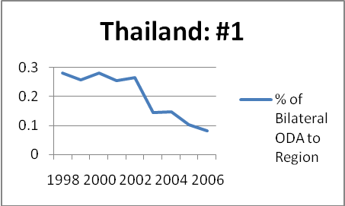
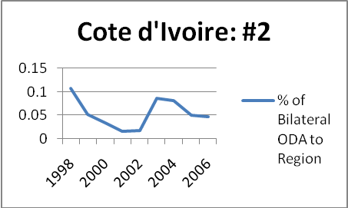
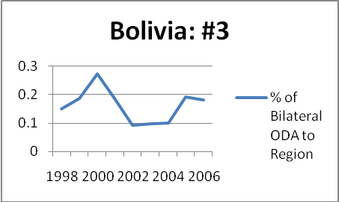
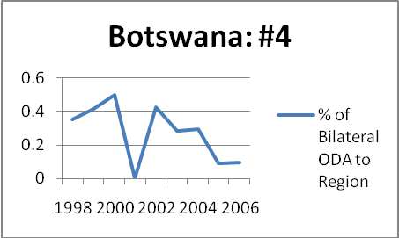
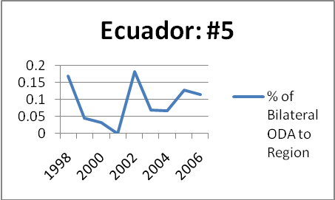
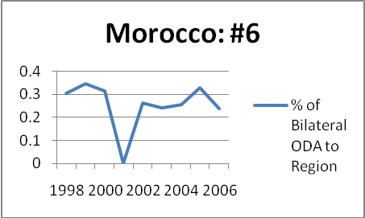
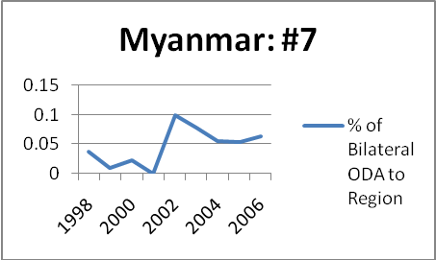
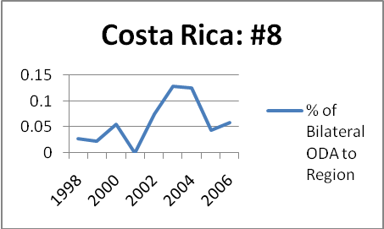
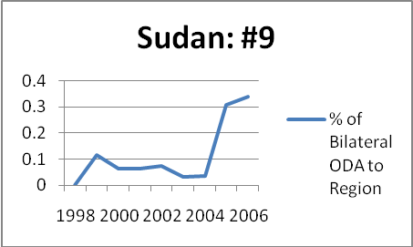

Appendix #5
Bilateral ODA Provision to Worst Market orientation Performers 1998-2006

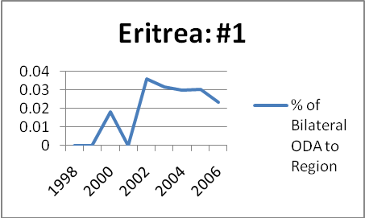
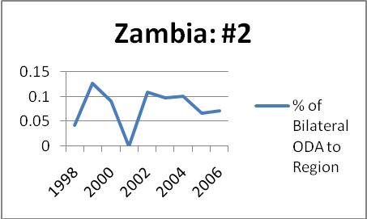
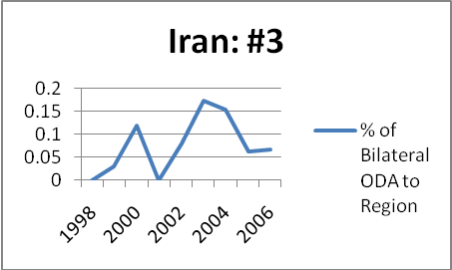
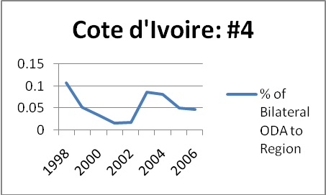
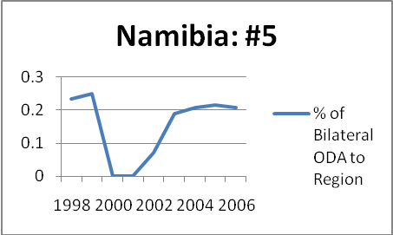
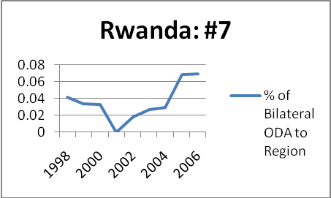
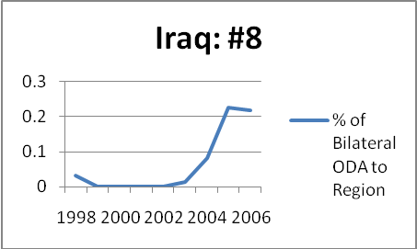
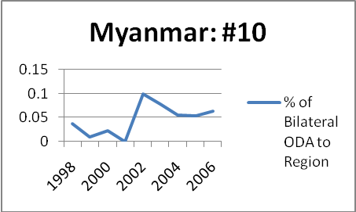
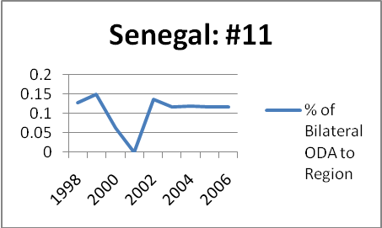
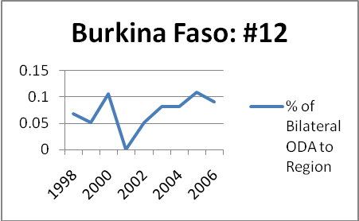

Endnotes

The Bertelsmann Index scores country performance on three indices, two of which are pertinent for the study: Political Transformation and Economic Transformation.
Japan’s initiative in taking a more pro-U.S. orientation is noted also by Watanabe (2005:3) and Nakanishi (2002:184-185).
Clooney (2007) offers that Japan must alter its free-rider orientation in international affairs that developed under the Yoshida Doctrine and is supported by many Japanese. This has resulted in Japan’s relative inability “to act as a major world player.” An interviewed Diet member in 1998 stated that, “[T]he problem is that Japan is having to do something more, and Japan needs principles to guide its foreign policy, currently it has none in foreign policy” (195).
For a more detailed discussion of Japan’s limitations in these regards and the additional challenges to its foreign policy as a product of the 1991 Persian Gulf War, see Nakanishi (2002: 184-185).
Certainly there have been notable exceptions to this – particularly with regard to some unsavory regimes during the cold war.
See also Arase (1993: 935-952) and Diamond (1995: 62).
Interesting here is that in places where these differing efforts converge, it increases the likelihood of their mutual suboptimal outcomes. For a fuller treatment of this conundrum see Stanley Hoffman, Duties beyond Borders: On the Limits and Possibilities of Ethical International Politics (New York: Syracuse University Press, 1981.) Clear (2008) makes clear the rub here with regard to Japan’s relations with Indonesia (its largest ODA recipient) and the East Timor crisis (230).
At the 1993 United Nations Human Rights Convention in Vienna, Japan acknowledged and supported the universality of human rights – whereas it had previously recognized a regional and divisible orientation.
With regard to Japan’s Middle East foreign policy, Miyagi (2008) notes that “Japan has explicitly used economic assistance as a substitute for a military approach in dealing with conflicts and security issues in the region – what might be called ‘strategic ODA’” (43).
Padilla (in Tujan, 2008) echoes Tujan in saying that “such loans require the recipient country to acquire most, if not all, to the technical assistance, equipment or commodities from the corporations of the donor-country”(25). See also Bahagijo in the same volume, p. 43.
Reiko notes that in 2002 ODA grant monies exceeded that of loan type but only by a small margin (5.3%) while nearly all other major donor countries exceeded 90% as grant type (37). Tujan (2008) also speaks to this issue claiming it “as the most controversial in Asia” with intensifying protests from communities in Asia regarding the displacement by different Japan ODA funded infrastructure projects – most frequently economic infrastructure projects (1).
Akira and Yasutami (1999) defend Japanese ODA figures after 1993 noting its high untied rate for bilateral loans compared to other wealthy donor countries and highlight the fact that Japanese corporations win less than 30% of the bids (203-204).
Miyagi (2008) notes while tied bilateral ODA has the advantage of “potentially gaining some leverage over recipient states,” its major contributions to international organizations wins Japan prestige and an international leadership role. Additionally, the latter form of ODA is “also congruent with UN-centric national norms” (44).
For a more methodologically sophisticated treatment of this issue, see Tuman and Strand (2005).
On a cautionary note, one must keep in mind the fact that once aid is accepted by the recipient, the provider loses all control over how the funds are utilized. Bluntly put, the recipient can play the provider for the sucker. Authoritarian regimes (such as those cases under scrutiny here) are notorious for using such funds to bolster their regimes rather than for intended purposes. Investigating fraud and corruption in specific cases is outside the scope of this study and is better left to case studies.
These are Hungary, Lithuania, Poland and Slovakia.
As used here - East Asia, Southeast Asia, South & Central Asia and Oceania combined.
Akira and Yasutumi (1999) see it as “slightly incongruous…that this classification system should divide infrastructure into two separate categories, social infrastructure and economic infrastructure. To be sure, in practice, this distinction is quite extensively used, but the criteria on which it is based do not seem logical, and consequently there is no established way of defining the boundary between them. Water services, for example, are regarded as economic infrastructure by some, whereas others make a distinction between industrial water supply and water for living purposes. In the DAC classification system, water supply and drainage are included under social infrastructure” (216). This concern is noteworthy but probably should not distract us. We must assume that this is a categorization convenience and that the bulk of aid is marked for human and social development rather than supporting economic infrastructure projects.
According to Nakanishi (2002), “Japan’s relative international aid contribution, which amounted to 20 per cent of that given by all states during the 1990s, fell to around 10 per cent by 2003. This reduction has been justified and accepted ‘internationally,’ and most importantly by the US, as Japan’s military contribution to international crises has correspondingly grown” (49-51). References Akira, Nishigaki and Shimomura Yasutami, The Economics of Development Assistance: Japan’s ODA in a Symbiotic World, Tokyo: LTCB International Library Foundation, 1999). Arase, David, “Japanese Policy toward Democracy and Human Rights in Asia,” Asian Survey 33, no. 10 (October 1993). Bahagijo, Sugeng, “Japan ODA in Indonesia and its Conditionality” in Antonio Lujan, Jr. , ed. Japan ODA: Development or Profit? (Manila, Philippines: Asia-Pacific Network, 2001). Clear, Annette, “International Aid and Political Change in Southeast Asia” in Anne Marie Murphy and Bridget Welsh, eds. Legacy of Engagement in Southeast Asia (Singapore: ISEAS Publications, 2008). Clooney, Kevin J., Japan’s foreign policy since 1945 (Armonk, NY: M.E. Sharpe, 2007). Diamond, Larry, Promoting Democracy in the 1990s: Actors and Instruments, Issues and Imperatives (New York: Carnegie Corporation, December 1995). Eiichi, Hoshino, “Economic Sanctions against Myanmar,” in Nishihara Masashi, ed., The Japan-U.S. Alliance: New Challenges for the 21st Century (New York, NY: Japan Center for International Exchange, 2000). Krauss, Ellis S. and T.J. Pempel, “Conclusion: Beyond Bilateralism – Toward Divided Dependence” in Ellis S. Krauss and Pempel, T.J., eds. Beyond Bilateralism: U.S.-Japan relations in the new Asia-Pacific (Stanford, CA: Stanford University Press, 2004). Lujan, Antonio, Jr., ed. Japan ODA: Development or Profit? (Manila, Philippines: Asia-Pacific Network, 2001). Ministry of Foreign Affairs (MOFA), The Diplomatic Bluebook, Tokyo, 1991. Miyagi, Yukiko, Japan’s Middle East security policy: theory and cases (New York: Routledge, 2008). Ministry of Foreign Affairs of Japan (MOFA, 2003) http://www.mofa.go.jp/policy/oda/reform/revision0307.html (Accessed: 20 August 2009). Ministry of Foreign Affairs of Japan (MOFA, 1991) http://www.mofa.go.jp/POLICY/other/bluebook/1991/1991-contents.htm (Accessed: 25 August 2009). Ministry of Foreign Affairs of Japan (MOFA, 1995) http://www.mofa.go.jp/policy/oda/white/index.html (Accessed: 22 August 2009). Nakanishi, Nakanishi “Japanese Relations with the United States” in Vogel, Ezra F., Yuan Ming, and Akihiko Tanaka eds., The Golden Age of the U.S.-China-Japan Triangle, 1972-1989 (Cambridge MA: Harvard University Press, 2002). Official Development Assistance by Japan, Book 1, 1995, Economic Cooperation Bureau of the Japan (Japan: Ministry of Foreign Affairs). Padilla, Arnold J., “Japan’s ODA: Obstructing Development through Aid?” in Antonio Lujan, Jr. , ed. Japan ODA: Development or Profit? (Manila, Philippines: Asia-Pacific Network, 2001). Patrick, Hugh, “The Transformative Role of Japan’s Official Development Assistance” in Anne Marie Murphy and Bridget Welsh, eds. Legacy of Engagement in Southeast Asia (Singapore: ISEAS Publications, 2008). Reiko, Inoue, “High Rate of Loan in Japanese ODA and Debt” in Fifty Years of Japan ODA: A critical review for ODA reform (Manila, Philippines: IBON Books, 2005). Takeda, Yasuhiro, “Democracy Promotion Policies: Overcoming Japan-U.S. Discord” in Ralph A. Cossa ed. Restructuring the U.S.-Japan Alliance: Toward A More Equal Partnership (Washington D.C.: The Center for Strategic and International Studies, 1997). Tuman, J. P., Emmert, C. F. and Strand, J. R. , 2005-03-05 "Reconsidering Gaiatsu: The Political and Economic Determinants of Japan's Official Development Assistance" Paper presented at the annual meeting of the International Studies Association, Hilton Hawaiian Village, Honolulu, Hawaii Online <.PDF>. 2009-05-26 from http://www.allacademic.com/meta/p70108_index.html U.S. Department of State (1993) http://www.state.gov/www/issues/economic/trade_reports/index.html (Accessed: 12 August 2009) Watanabe, Tatsuya, “History of Japan’s ODA in brief” in Fifty Years of Japan ODA: A critical review for ODA reform (Manila, Philippines: IBON Books, 2005).

